Design, develop and implement recursively subdivide a tetrahedron to form 3D sierpinski gasket. The number of recursive steps is to be specified by the user.(LAB PROGRAM)

#include <stdlib.h>
#include <stdio.h>
#include <GL/glut.h>
typedef GLfloat point[3]; //Three coordinates x, y,z values
point v[]={{-1.0,-0.5,0.0},{1.0,-0.5,0.0},{0.0,1.0,0.0}, {0.0,0.0,1.0}}; // 4 vertices
GLfloat colors[4][3]={{1.0,0.0,0.0},{0.0,1.0,0.0},{0.0,0.0,1.0},{1.0,1.0,0.0}};// color for four faces of tetrahedron
int n;// no of divisions
void triangle(point a,point b,point c) // creating a face of tetrahedron
{
glBegin(GL_POLYGON);
glVertex3fv(a);
glVertex3fv(b);
glVertex3fv(c);
glEnd();
}
void tetra(point a,point b,point c,point d) // representation of the tetrahedron
{
glColor3fv(colors[0]);
triangle(a,b,c); // face-1
glColor3fv(colors[1]);
triangle(a,c,d); //face-2
glColor3fv(colors[2]);
triangle(a,d,b); // face-3
glColor3fv(colors[3]);
triangle(b,d,c); // face-4
}
void divide_tetra(point a,point b,point c,point d,int m) // perform division
{
point mid[6];
int j;
if(m>0)
{
for(j=0;j<3;j++) // generating the bisetors for each edge
{
mid[0][j]=(a[j]+b[j])/2.0; // mid0 between a and b
mid[1][j]=(a[j]+c[j])/2.0; // mid1 between a and c
mid[2][j]=(a[j]+d[j])/2.0; // mid2 between a and d
mid[3][j]=(b[j]+c[j])/2.0; //// mid3 between b and c
mid[4][j]=(c[j]+d[j])/2.0; // mid4 between c and d
mid[5][j]=(b[j]+d[j])/2.0; // mid5 between b and d
}
divide_tetra(a,mid[0],mid[1],mid[2],m-1); // apex tetrahedron
divide_tetra(mid[0],b,mid[3],mid[5],m-1); // left corner
divide_tetra(mid[1],mid[3],c,mid[4],m-1); // front
divide_tetra(mid[2],mid[5],mid[4],d,m-1); // right
}
else
tetra(a,b,c,d);// creating the tetrahedron
}
void display()
{
glClear(GL_COLOR_BUFFER_BIT|GL_DEPTH_BUFFER_BIT);
glClearColor(1.0,1.0,1.0,1.0);
divide_tetra(v[0],v[1],v[2],v[3],n);
glFlush();
}
void myReshape(int w,int h)
{
glViewport(0,0,w,h);
glMatrixMode(GL_PROJECTION);
glLoadIdentity();
if(w<=h)
//glOrtho(-1,1,-1,1,-1,1);
glOrtho(-1.0,1.0,-1.0*((GLfloat)h/(GLfloat)w), 1.0*((GLfloat)h/(GLfloat)w),-1.0,1.0);
else
//glOrtho(-1,1,-1,1,-1,1);
glOrtho(-1.0*((GLfloat)w/(GLfloat)h),1.0*((GLfloat)w/(GLfloat)h),-1.0,1.0,-1.0,1.0);
glMatrixMode(GL_MODELVIEW);
glutPostRedisplay();
}
void main(int argc,char ** argv)
{
printf( "No of Division?: ");
scanf("%d",&n);
glutInit(&argc,argv);
glutInitDisplayMode(GLUT_SINGLE|GLUT_RGB|GLUT_DEPTH);
glutInitWindowSize(500,500);
glutCreateWindow( "3D gasket" );
glutDisplayFunc(display);
glutReshapeFunc(myReshape);
glEnable(GL_DEPTH_TEST);
glutMainLoop();
}

**** Output ***

No. of Divisions ? 2

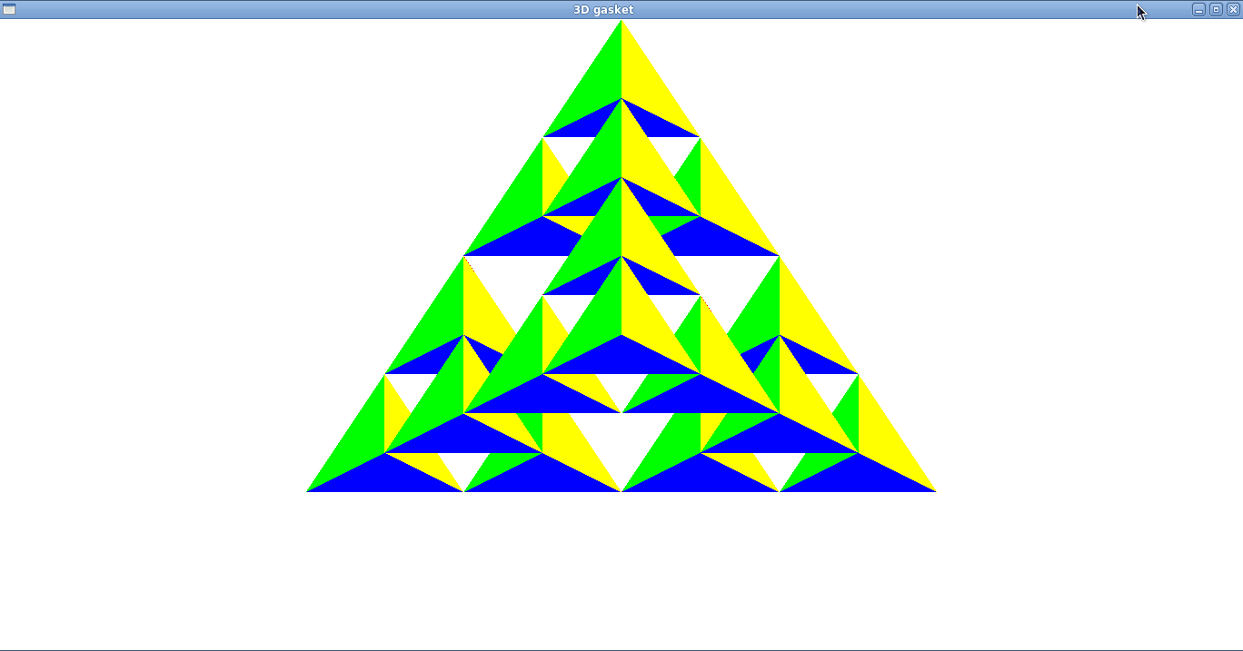

No. of Divisions ? 3
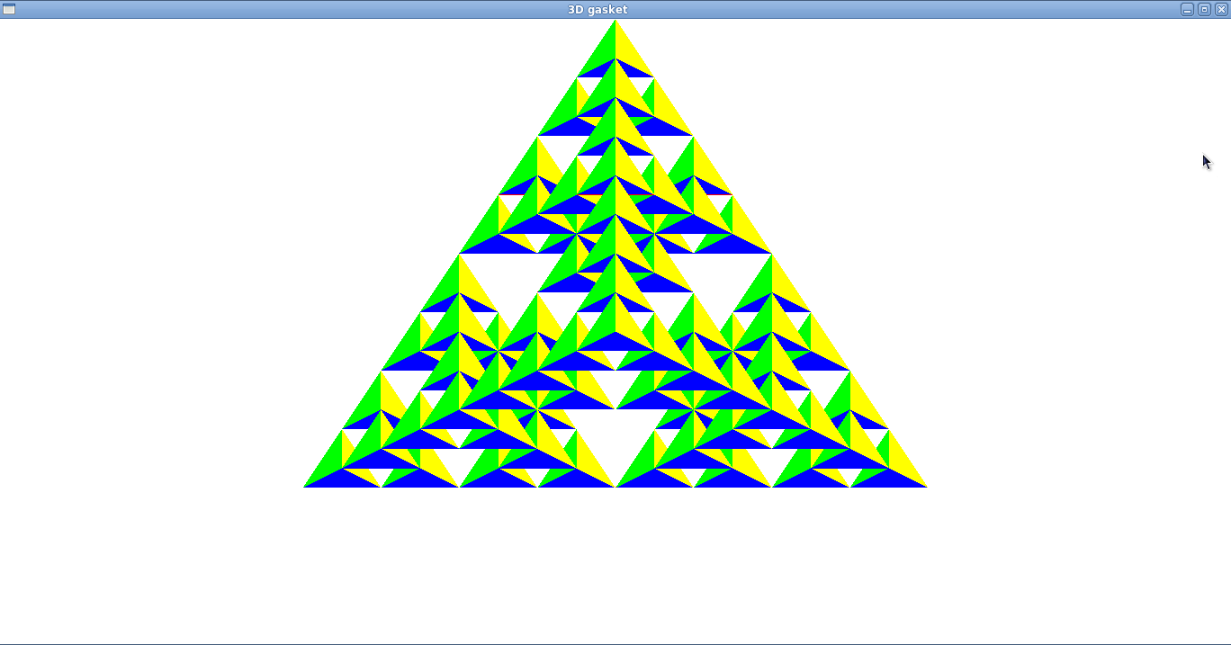

2D RECURSIVE SIERPINSKI
#include<stdio.h>
#include<GL/glut.h>
int n;
typedef GLfloat point2[2];
point2 v[3]= {{-2,-1}, {2,-1},{0,1}};
void triangle( GLfloat *a, GLfloat *b, GLfloat *c)
/* display one triangle */
{
glVertex2fv(a);
glVertex2fv(b);
glVertex2fv(c);

}
void divide_triangle(GLfloat *a, GLfloat *b, GLfloat *c, int m)
{
/* triangle subdivision using vertex numbers */
point2 v0, v1, v2;
int j;
if(m>0)
{
for(j=0; j<2; j++) v0[j]=(a[j]+b[j])/2;
for(j=0; j<2; j++) v1[j]=(a[j]+c[j])/2;
for(j=0; j<2; j++) v2[j]=(b[j]+c[j])/2;
divide_triangle(a, v0, v1, m-1);
divide_triangle(c, v1, v2, m-1);
divide_triangle(b, v2, v0, m-1);
}
else(triangle(a,b,c));
/* draw triangle at end of recursion */
}
void display()
{
glClear(GL_COLOR_BUFFER_BIT);
glBegin(GL_TRIANGLES);
divide_triangle(v[0], v[1], v[2], n);
glEnd();
glFlush();
}
void myinit()
{
glMatrixMode(GL_PROJECTION);
glLoadIdentity();
gluOrtho2D(-2.0, 2.0, -2.0, 2.0);
glMatrixMode(GL_MODELVIEW);
glClearColor (1.0, 1.0, 1.0,1.0);
glColor3f(1.0,0.0,0.0);
}
int main(int argc, char **argv)
{
printf("Enter the number of divisions\n");
scanf("%d",&n);
glutInit(&argc, argv);
glutInitDisplayMode(GLUT_SINGLE|GLUT_RGB);
glutInitWindowSize(500, 500);
glutCreateWindow("2D Gasket");
glutDisplayFunc(display);
myinit();
glutMainLoop();
return 0;
}
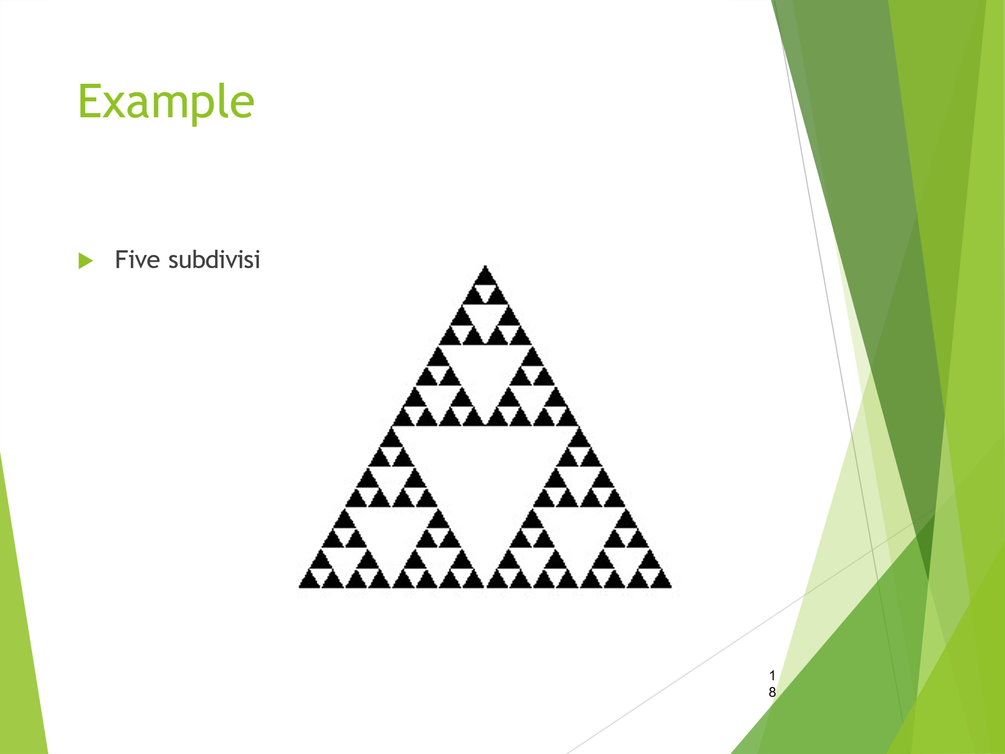

2D RANDOM SIERPINSKI GASKET
#include<stdio.h>
#include<GL/glut.h>
#include<stdlib.h>
int n;

void display()
{
GLfloat vertices[3][3]={{0.0,0.0,0.0},{25.0,50,0.0},{50.0,0.0,0.0}};
GLfloat p[3]={7.5,5.0,0.0};

int j, k;
int rand();
glClear(GL_COLOR_BUFFER_BIT);
glBegin(GL_POINTS);
for(k=0;k<n;k++)
{ j=rand()%3;

p[0]=(p[0]+vertices[j][0])/2;
p[1]=(p[1]+vertices[j][1])/2;
glVertex3fv(p);
}
glEnd();
glFlush();

}

void myinit()
{ glClearColor (1.0, 1.0, 1.0,1.0);
glColor3f(0.0,0.0,0.0);
glMatrixMode(GL_PROJECTION);
glLoadIdentity();
gluOrtho2D(0.0, 60.0, 0.0, 60.0);
//glMatrixMode(GL_MODELVIEW);

}
int main(int argc, char **argv)
{
printf("Enter the number of divisions\n");
scanf("%d",&n);

glutInit(&argc, argv);
glutInitDisplayMode(GLUT_SINGLE|GLUT_RGB);
glutInitWindowSize(500, 500);
glutCreateWindow("2D Gasket");
glutDisplayFunc(display);
myinit();
glutMainLoop();
}

